March 2017 PTA Newsletter
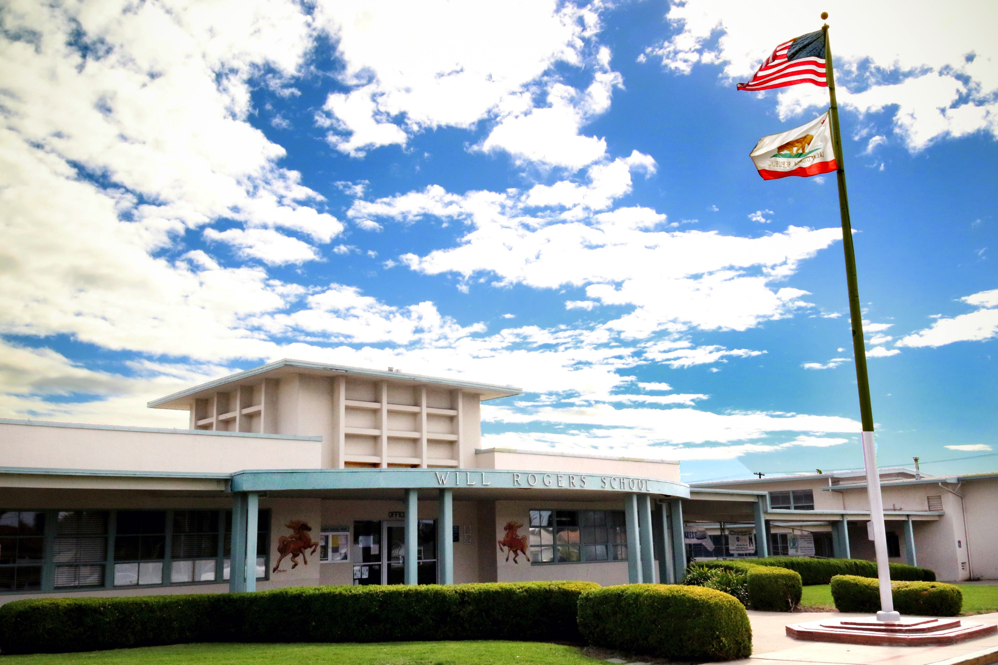

Upcoming Events

March 7

Restaurant Night @Snapper Jacks on Telegraph Rd. 11am-9pm

March 9

Family Reading Night

March 9-14

Parent-Teacher Conferences Begin, Early

Dismissal

March 15

Kindergarten Registration Begins

March 21

PTA General Meeting @6:30pm

March 25

C-St Beach Clean Up (by pier) 9-11am

C St. Beach Clean Up Day March 25th – ‘C’ Street / Surfer’s Point, Ventura – 9-11am, Meet at end of Promenade All volunteers must sign a liability waiver (see WR website) and anyone under 18 needs adult supervision RSVP required - please email Julie at jsalomonson@yahoo.com.
Calling all Painters! PTA is looking for parents to help paint the bookshelves in the library. This is the final step in the Will Rogers Library renovation! The painting day will take place on a Saturday in April (exact date TBD). If you can stop by for 1-2 hours to help, please email Nani Oesterle (wainani@gmail.com).

https://www.facebook.com/groups/WillRogersElementaryPTA
Please come to the PTA meeting on 3/21 from 6:30-8:00 pm! Dr. Cortes will discuss the new Student Leadership Program at Will Rogers. Childcare and translation will be provided.

Family Reading Night – Thursday, March 9th!
Put on your pajamas and join us for a fun celebration of bilingual literacy at our Family Reading night on Thursday, March 9th 6-8pm in the cafeteria! Dr. Kathleen Contreras will be our guest author reading her new book Sweet Memories/ Dulces Recuerdos. Signed books will be available for purchase after the reading. Activities will include crafts, popsicle treats, popcorn, and a book give-away. The evening will conclude with the presentation of Read-a-thon awards. Don’t miss this free and fun event!
Save the Date! Carnival is Friday, April 28th!
Please join us in our spring fundraiser at Carnival! It is a fun family night with games, food, Book Fair, and our silent auction! Look for an invitation on Facebook! We hope to see you there!
Carnival is Coming! Auction Items Needed!
Our Spring Carnival and Silent Auction is approaching quickly! Please help by asking for donations! Popular items include: gift cards for kid’s classes and activities, restaurant gift cards, popular children’s toys/movies/books, and gift cards to goods/services. Don’t know where to start? Let your auction co-chairs, Micaela Swafford (Micaela.Swafford@gmail.com) and Kristy Lim (Kristy.Lim@gmail.com) guide you! Contact us if you can help. We can’t wait to raise money for all of our music, CODE, and other extracurricular programming!!!
Want to Join the PTA and Make a Real Impact on the School?
We are looking for parents to join our team in these roles: President, Secretary, Treasurer, Parliamentarian, and Historian. Give your time and make a difference! Board elections are in April! Please contact Rachel McClanahan at Rach.McClan@gmail.com

